**PROJECT REPORT TEMPLATE**

**Retail Management Application using Salesforce**

**1 INTRODUCTION**

**1.1 Overview**

Salesforce for Retail is a set of solutions built on the Salesforce platform designed to help retail companies manage their operations and customer relationships. These solutions include tools for managing inventory, sales, customer data, marketing, and more. They can be customized to meet the specific needs of different retailers, including fashion, home goods, and other specialty retailers.

**1.2 Purpose**

The purpose ofSalesforce in Retail Management is to manage orders from retail stores and distributors, including tracking orders, processing payments, and managing inventory levels. This can help field sales teams ensure that orders are fulfilled quickly and accurately and that inventory levels are maintained at optimal levels.

**2 PROBLEM DEFINITION & DESIGN THINKING**

**2.1 Empathy Map**

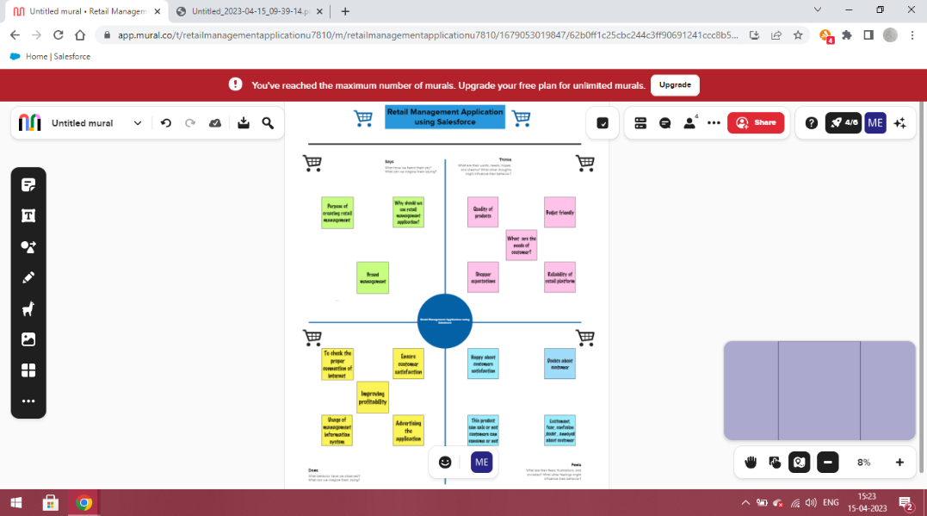

**2.2 Ideation & Brainstorming Map**

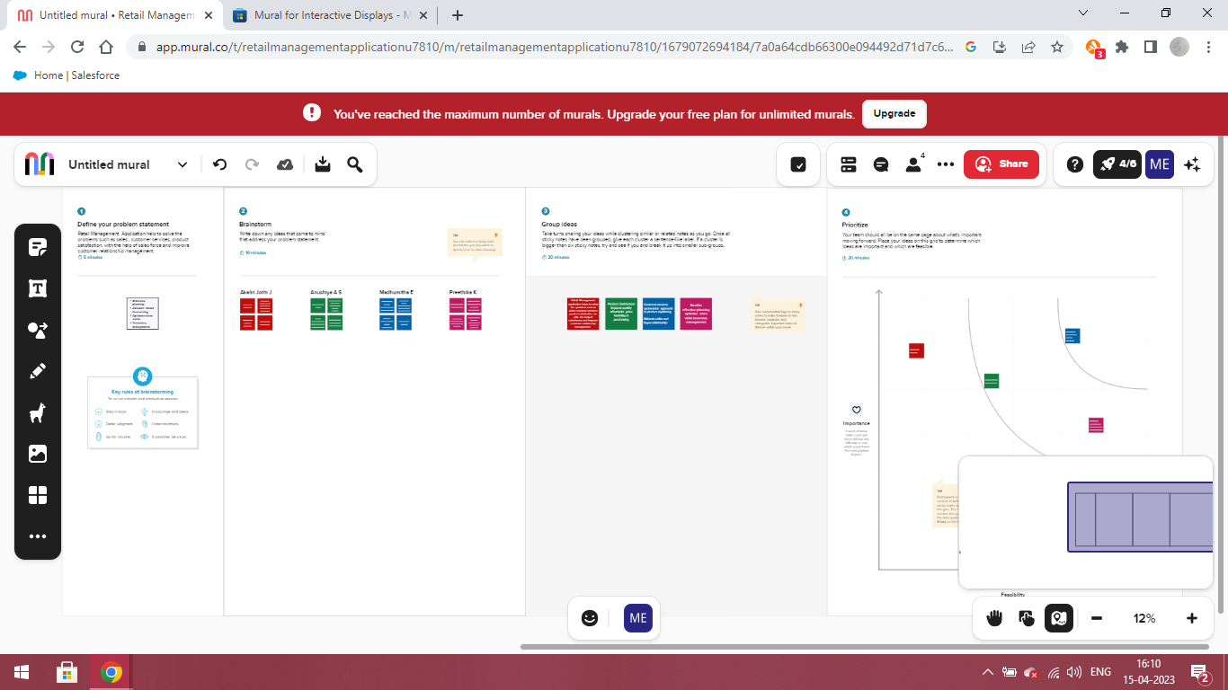

**3 RESULTS**

**3.1 Data Model**

|  |  |
| --- | --- |
| **Object Name** | **Fields in the Object** |
| Dispatch / Tracking | |  |  | | --- | --- | | **Field label** | **Data type** | | Dispatched | Check box | | Sales order | Master detail relationship | |
| Contact | |  |  | | --- | --- | | **Field label** | **Data type** | | Account website | Data type | |

**3.2 Activity & Screenshot**

**Milestone -1**

**Activity**

* Creating developer account

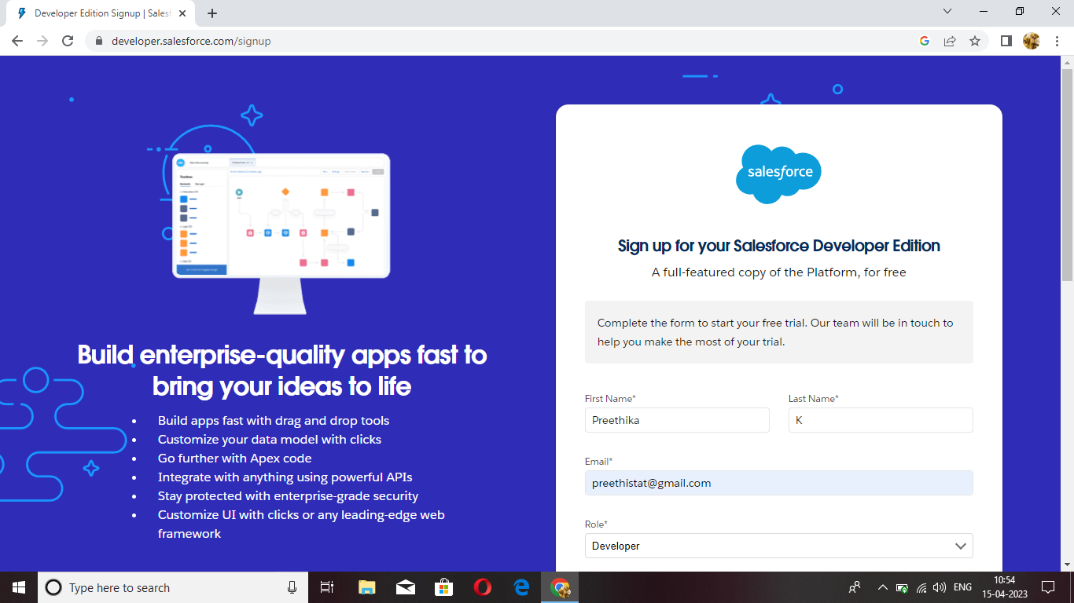

* Account activation

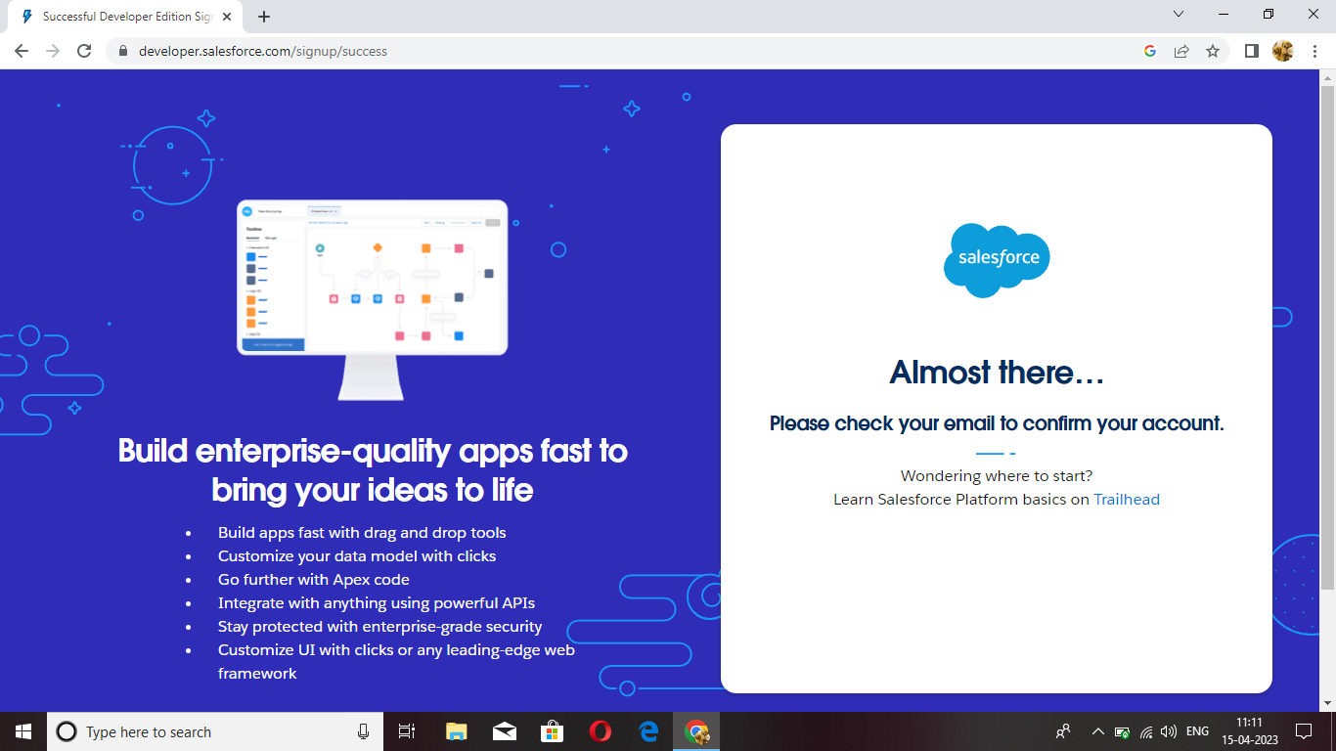

* Login to salesforce account

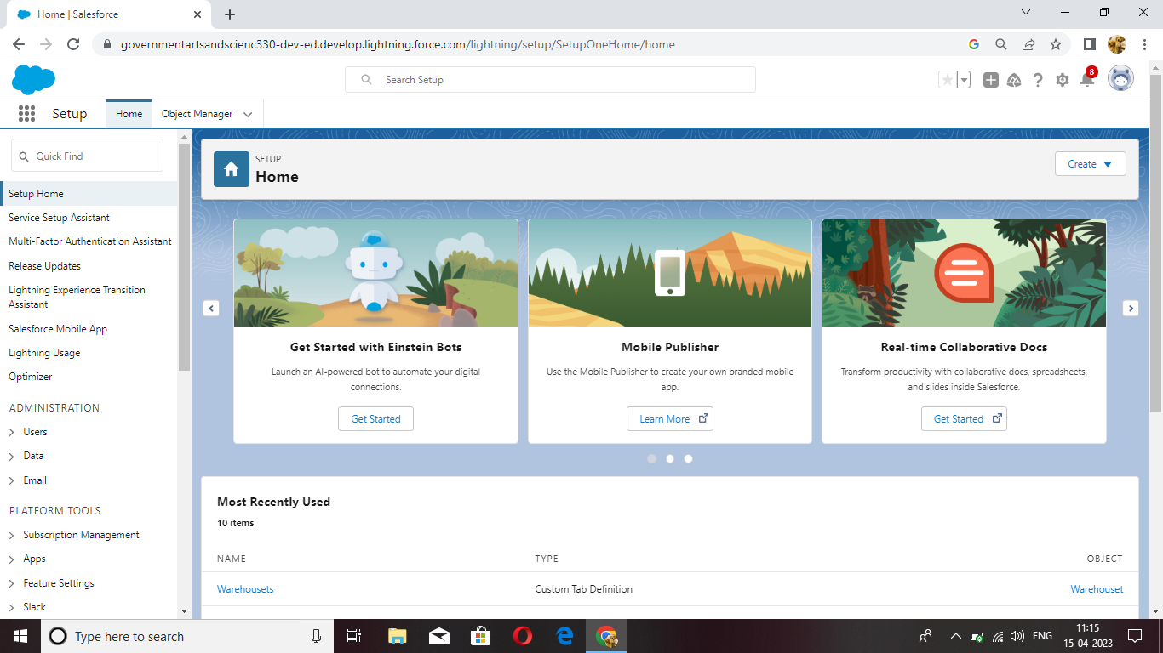

**Milestone -2 Objects**

**Activity-1**

Creation of object Dispatch/Tracking

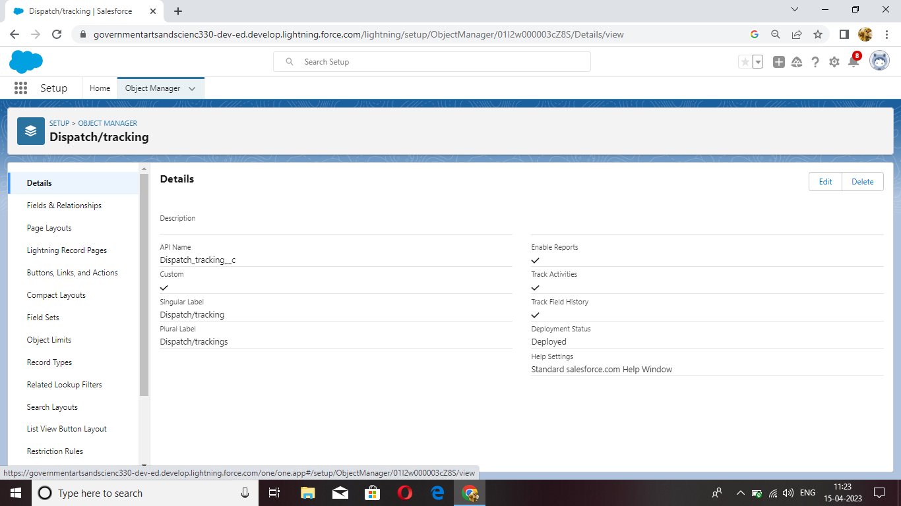

**Activity -2**

Creation of fields on Dispatch/Tracking

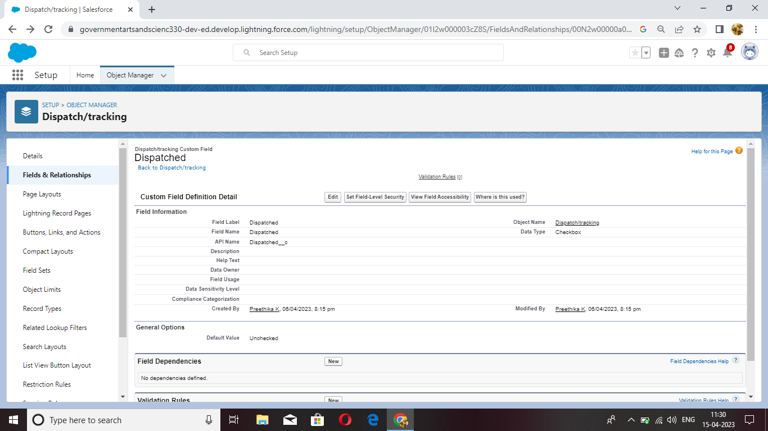

**Milestone -3 Relationship b/w objects**

**Activity**

Creation of relationships between objects Dispatch/tracking and sales order

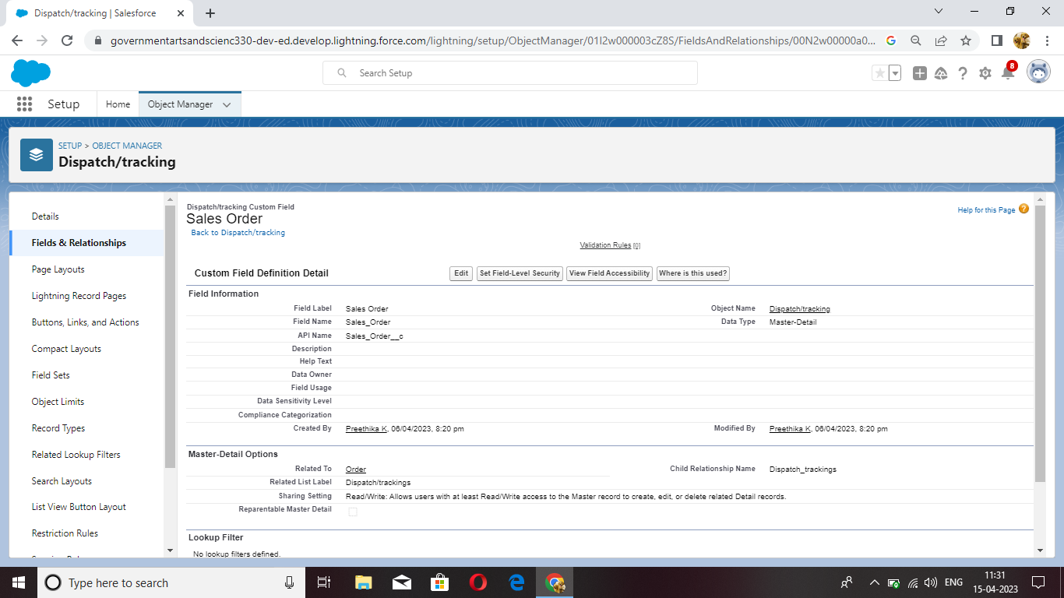

**Milestone -4 Application**

**Activity**

Creation of application

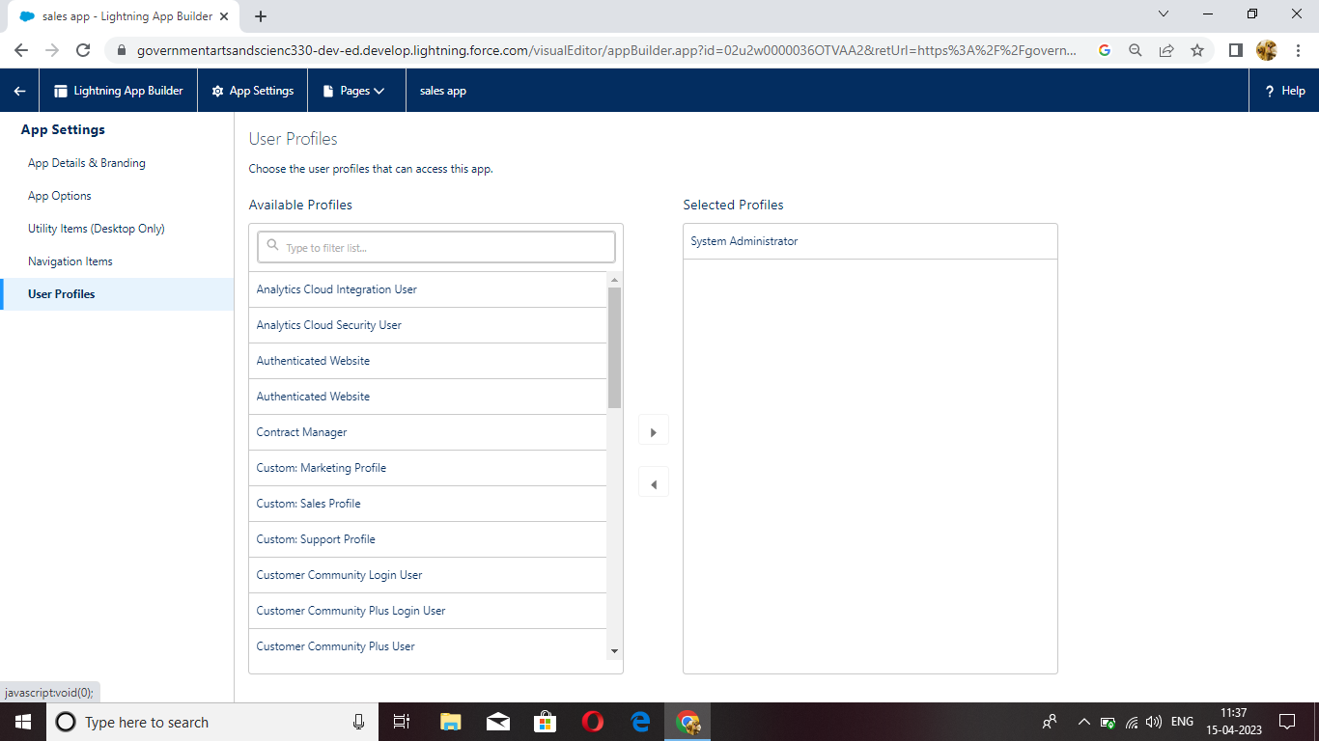

**Milestone -5 Layouts**

**Activity**

Creation of custom tabs such as warehouse, students and parents

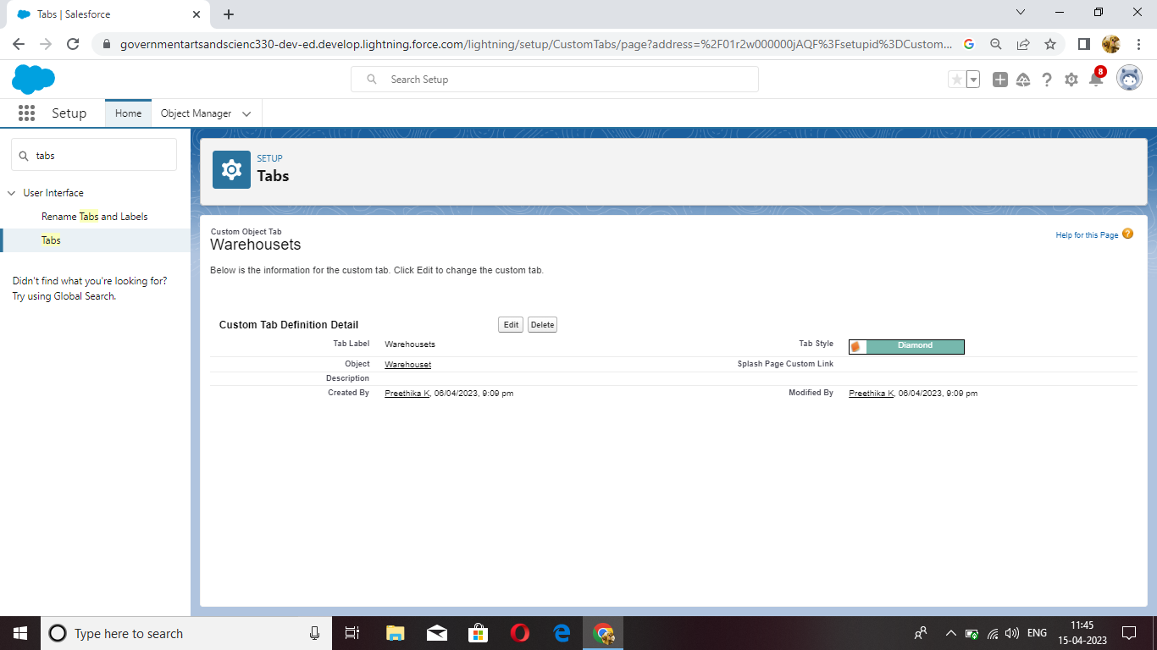

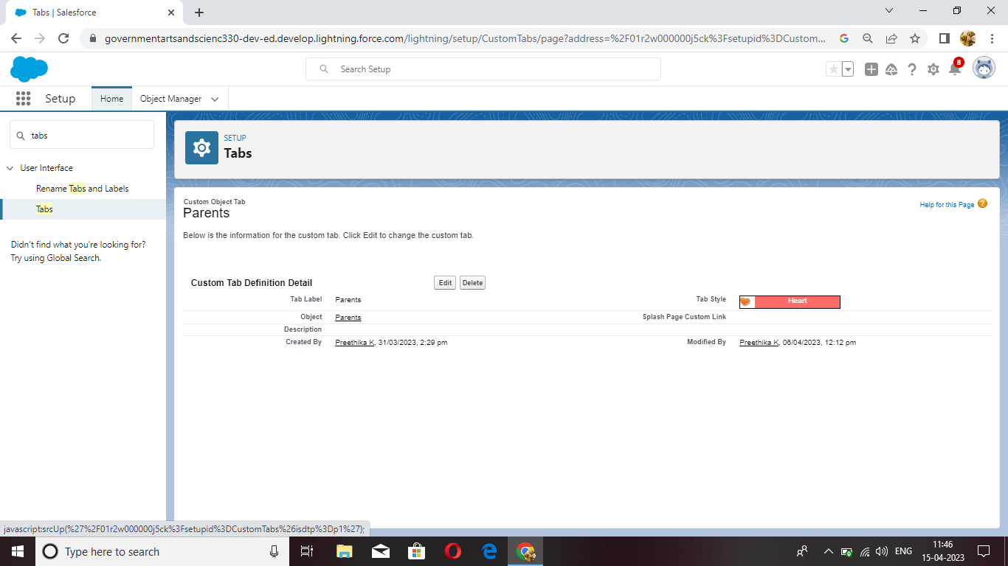

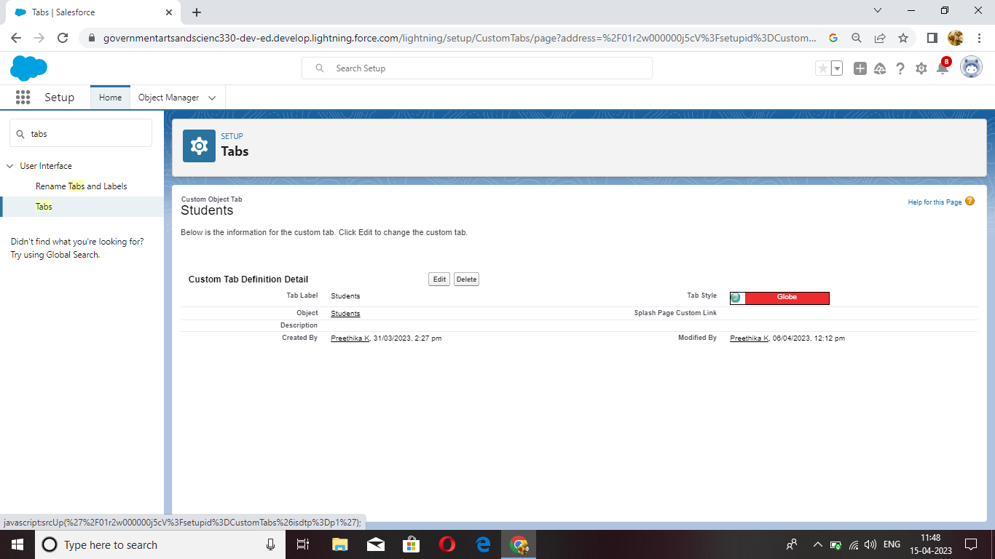

**Milestone -6 User**

**Activity**

Creation of User. Users are employees at a company, such as sales reps, managers, and IT specialists, who need access to the company’s records.

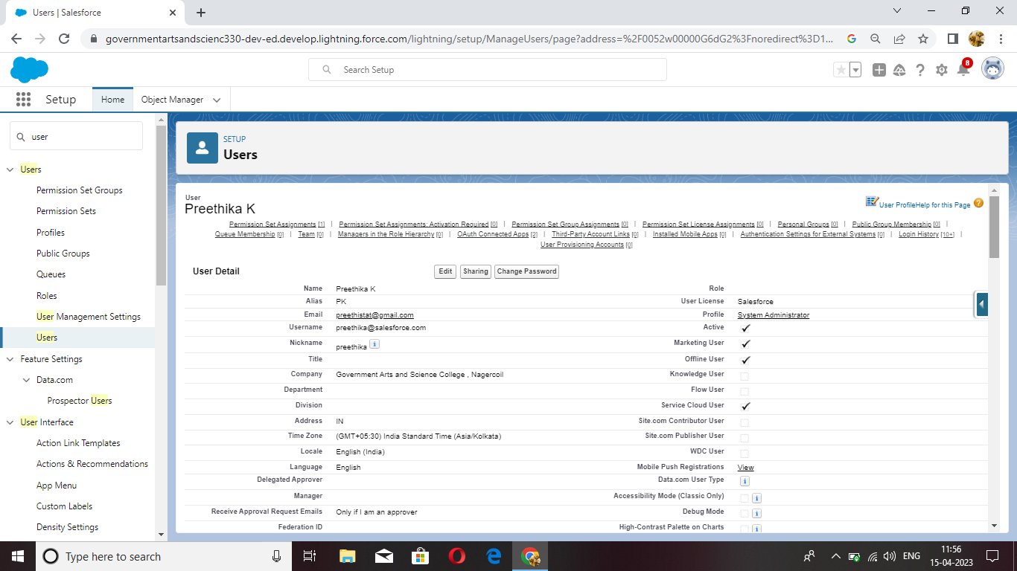

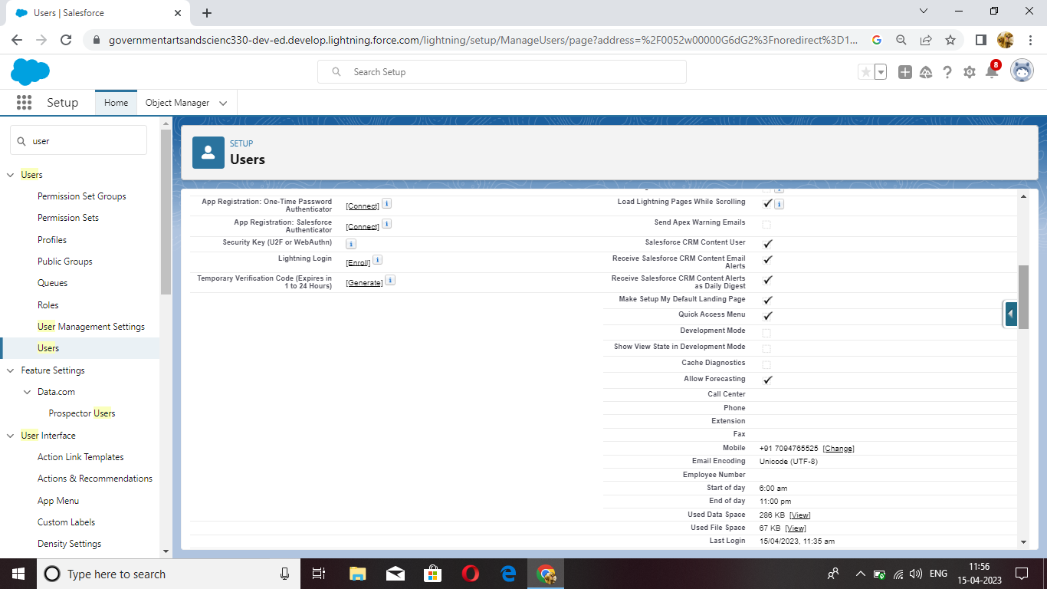

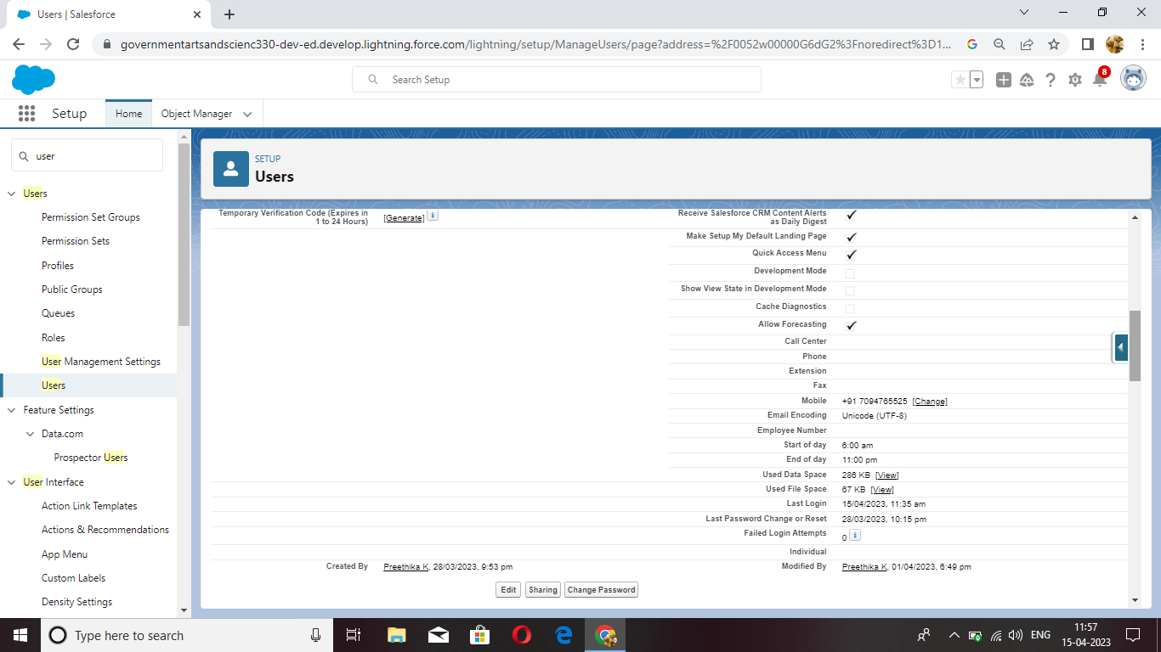

**Milestone -7 Validation Rules**

**Activity -1**

Creation of validation rule

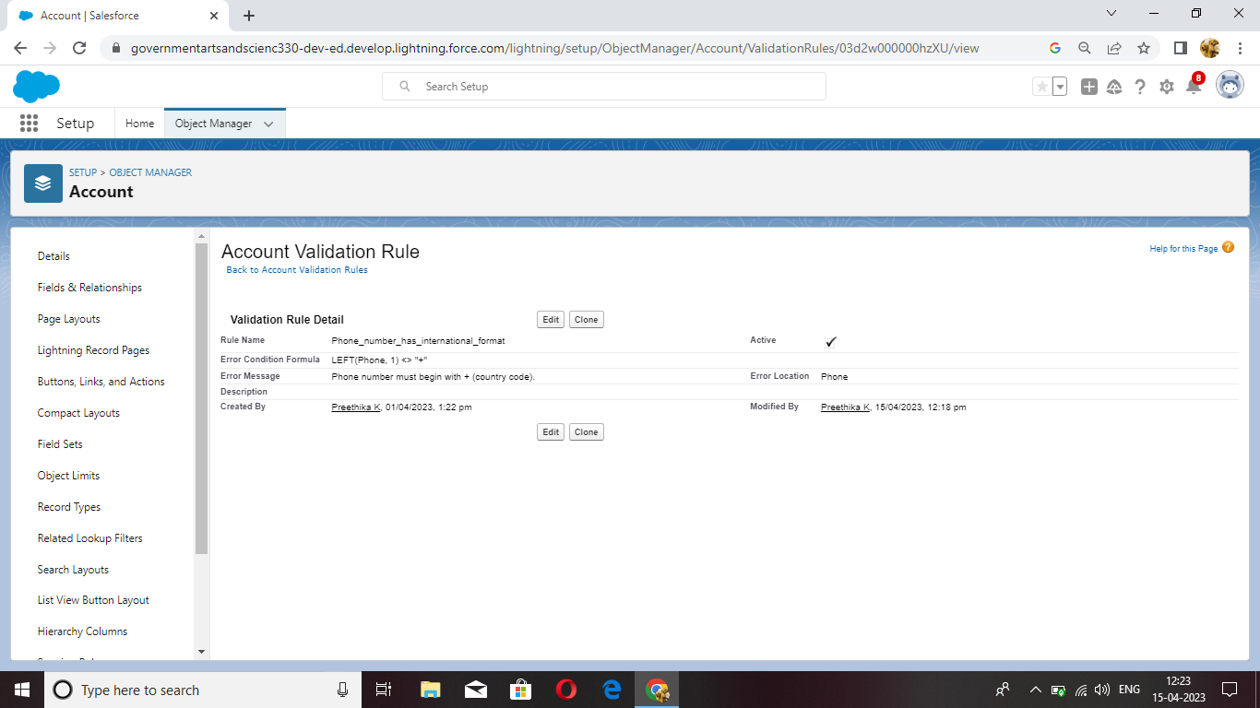

**Activity -2**

Creation ofcross object

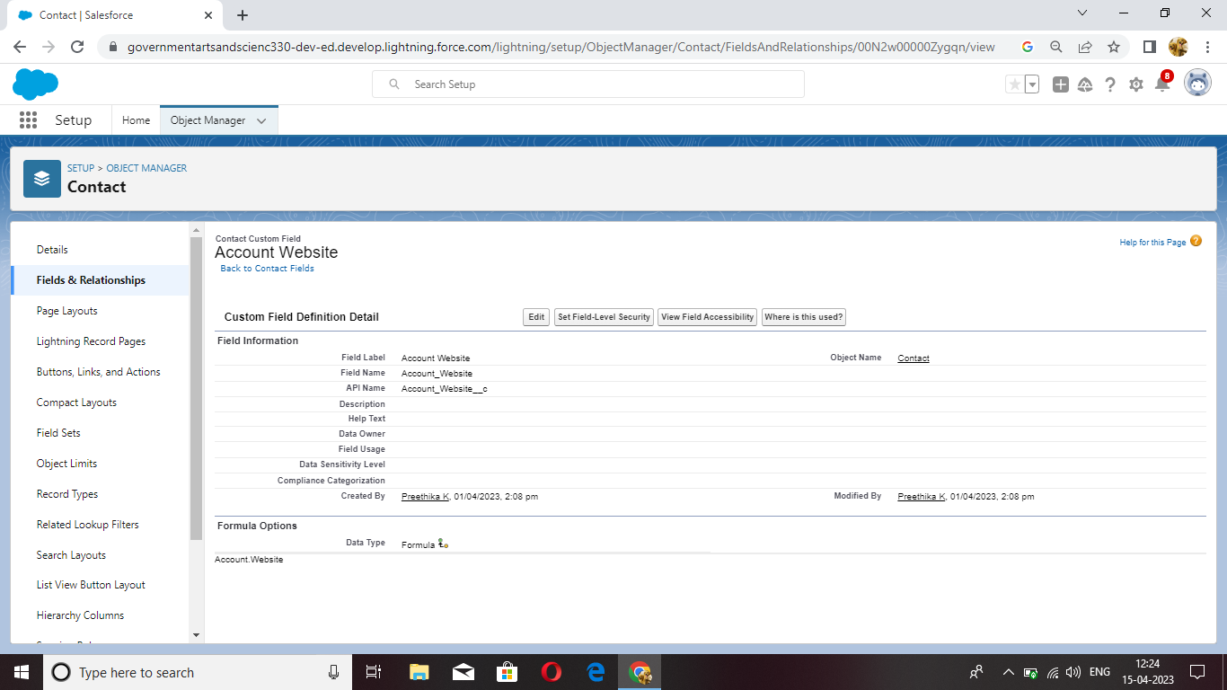

**Milestone -7 Reports**

**Activity**

Creation of report

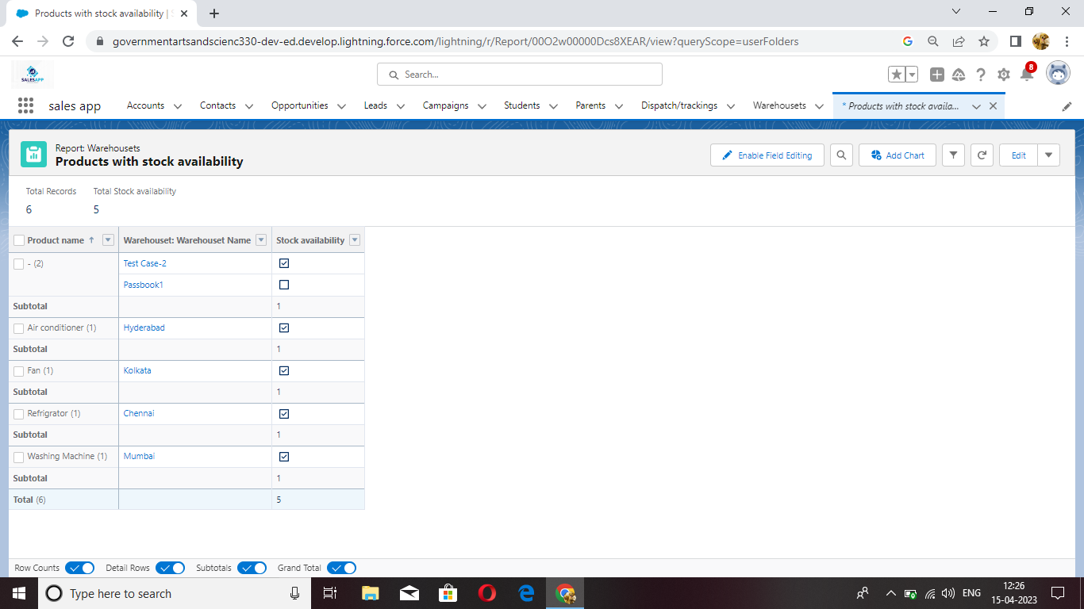

**Milestone -8 Dashboards**

**Activity**

Creation of Dashboards

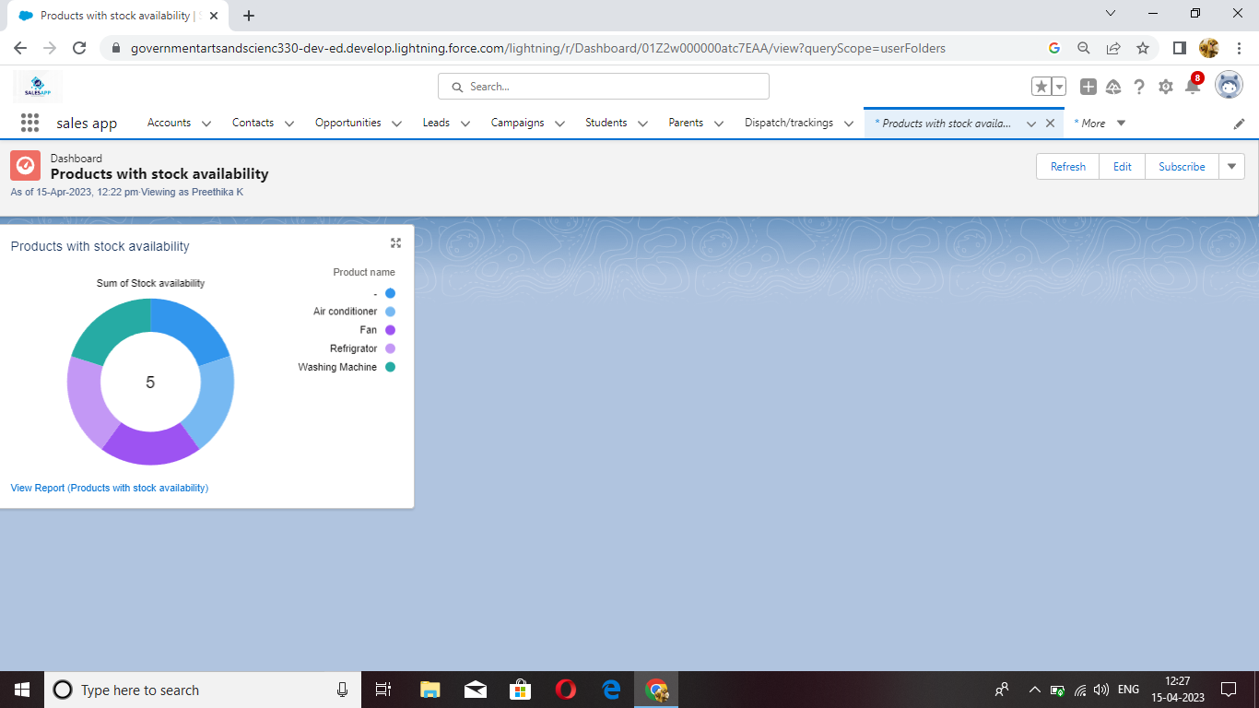

**4 TRAILHEAD PROFILE PUBLIC URL**

Team Lead - <https://trailblazer.me/id/akalin>

Team Member 1 - <https://trailblazer.me/id/abcdxyz1234>

Team Member 2 - <https://trailblazer.me/id/madhu118>

Team Member 3 - <https://trailblazer.me/id/preethistat>

**5 ADVANTAGES & DISADVANTAGES**

**Advantages**

* Salesforce provides a unified platform for managing customer interactions, which enables retailers to deliver personalized shopping experiences.
* Salesforce provides a centralized repository for managing customer, product, and sales data
* Salesforce integrates with leading e-commerce platforms and point-of-sale (POS) systems, making it easy for retailers to manage their inventory and ensure that products are always in stock.
* Retailers can use Salesforce to track customer behavior across multiple channels and deliver consistent, personalized experiences.
* Salesforce makes it easy for teams across different departments to collaborate and share information.

**Disadvantages**

* Expensive.
* You have to pay for add-ons to get the most out of the software.
* Configuration and setup a complex and time-consuming.
* Cluttered interface makes navigation and simple tasks unnecessarily complex.
* The learning curve never seems to end.

**6 APPLICATIONS**

* Tracking orders
* Processing payments
* Managing inventory levels

**7 CONCLUSIONS**

Sales Force in Retail Management Application is helps us to compress the business activities involved in selling goods and services to consumers for their personal, family, households etc. Here we learn to create custom objects, fields etc. up to creation of dashboards. These are helps all to work in Retail Management Application in Sales Force.

**8 FUTURE SCOPE**

The global retail management systems software market is projected to hit an

overall, USD 8.0 billion market size by 2028. This is majorly attributed to growing

willingness of retail businesses to invest money in new business models and

experiment with different retail formats.